ENGLISH FIRST ADDITIONAL LANGUAGE
GR. 10
SEPTEMBER
TEST
1½ Hour Marks: 100

INSTRUCTIONS
Answer all the questions
Begin the answers of Section B on a new page.
Draw a margin on the right hand side of the page
Handwriting that is not readable will not be marked.

SOCCER MADNESS

SOUTH AFRICAN SPORTING TRIVIA

1. What do we call the following national teams?
1.1 the women's soccer team?
1.2 the under-23 men's soccer team?
Banyana banyana
Amaglug-glug
(2)
2. SAFA is an acronym for the South African Football Association. What do the following sporting acronyms or abbreviations stand for?
2.1 UCB?
2.2 NOCSA?
2.3 CAF?
United Cricket Board
National Olympic Committee of South Africa
Confederation of South African Football
(3)

JARGON
Jargon is a specialised language that is used by people who share an interest or occupation. Different jobs. sports and hobbies all have their own jargon.

3. Look at the words below.
ballot box, try, chat room, dialysis, STD, caucus, penalty
3.1 Which of the words in nr. 3 belongs to political jargon?
ballot box
caucus
3.2 Which of the words in nr. 3 belongs to sporting jargon?
try
penalty
3.3 Which of the words in nr. 3 belongs to medical jargon?
STD
dialysis
3.4 Which of the words in nr. 3 belongs to Internet jargon?
chat room
(5)
CHANGING TENSES
4. The paragraph below is written in the past tense. Rewrite it, changing all the verbs and auxiliary verbs to the present tense. Write down only the number and the answer.

Liberia (4.1 replied) in the 79th minute, when Prince Daye (4.2 pounced) on the ball as it (4.3 rebounded) off the post and (4.4 got) the ball into the goal. A few minutes later, Liberian defender, Musa Shannon, (4.5 was) yellow-carded, after bringing Zuma down. However, the opportunity to score (4.6 was squandered) again as the free kick (4.7 floated) away from the danger area. Sifiso (4.8 was) mildly depressed, but only until the referee (4.9 blew ) the whistle and South Africa (4.10 had secured) a 2-1 victory against their old rivals.
(10)
5. SOCCER LOSES OUT AS OTHER DISTRACTIONS TEMPT THE KIDS

There is a loft of anxious talk, in the homes of soccer lovers, in bars and in boardrooms, about producing soccer players and furthering development, not only in South Africa but in he rest of the world as well.
But what can be done if players cannot be 'found'?
What is the interests of budding young stars are diverted in other directions? What do you do when the beautiful game is no longer recognised as such by the generations of our youth? This is not only a South African problem; it is a trend affecting world soccer in general. There are so many other attractions, form the dusty back streets of Brazil to the rainy stadiums of England. These days, football and other sports are taking a back seat.
The biggest problem that has emerged over the last few years is the arrival of home computer games. These are getting more and more advanced and they are now so realistic and sophisticated that they are capable of intriguing even the most ardent of sports lovers, who can now play their favourite sports in the comfort of their living rooms. Active players and avid fans alike are being turned into 'couch potatoes.'
This trend is especially problematic in the South African context. With a rising crime rate, and especially with the abuse of youngsters being so rife, parents are keen to spend money on something that will keep their kids off the streets. This is bad for the game of soccer because we are slowly losing out on potential footballers and the game is dying as a result.
Also, with soccer having rather a bad name as a result of the infiltration of our beloved teams by gangsters and other antisocial elements, parents are encouraging kids to channel their efforts in other directions. Gone are the days when kids used to come home from school and move straight into the street to play ball.
When parents arrived home from word, 'championships' games that were played by enthusiastic, barefoot young amateurs would end abruptly. The players - still dressed in their school uniforms - had to be dragged off the streets by their parents.
The street game made South African players what they are. It enabled them to learn close control and develop an ability to do almost anything with the ball at their feet.
The magic of Bafana Bafana was learned the hard way - kicking tired tennis balls, again and again, up and down the loud and lively streets of the townships we call home.
Now, we are lagging behind the rest of Africa in this respect because South Africans have so many other things to do, for instance TV to watch and shopping malls to go to. We are very much an exception on the continent.
In the rest of Africa, people don't have these luxuries. All they have to get them out of the ghettos is soccer, so the hunger to succeed is there. In South Africa it appears the youth are no longer so hungry and so soccer's need for new talent will not be fed.
England coach Kevin Keegan recently highlighted the same problem in England. This player of the past has recently voiced his concern about this situation in his home country, where the problem is growing at an alarming rate.
He even came close to criticising the manufacturers of these computer games. This is an issue that South African parents must also confront. What our children say they want is not always what they need.
The new generation of South Africans do not identify with soccer as their parents do; they do not want to go to stadiums on weekends to watch games because they are not gripping enough.
The game here in South Africa needs to be made more attractive so that more people will come to watch the clubs play. If you look around the stands during local games, there are very few youngsters in attendance.
Families should be encouraged to come to soccer more, and innovations should be put in place in a way that will 'force' people to come back out of a love for our national game.

Clinton Asary
5.1 Work out if the following statements are true or false. If a statement is false you must provide a reason, using your own words.
If not enough information is presented in the article to decide if the statement is true or false then write 'not enough evidence' . If you decide a statement is true, quote an extract from the passage that supports the statement or explain why you say the statement is true.

5.1.1 Producing good young soccer players is an international problem.
(2)
5.1.2 The phrase 'budding young stars' contains figurative language.
(2)
5.1.3 Most young people still spend most of their time on sport.
(2)
5.2 Vocabulary
5.2.1 What is the meaning of the phrase "taking a back seat"?
5.2.2 What is a 'ghetto'?
5.2.3 What is the meaning of "amateur'?
(3)
5.3 Write down one idea this article gives that could be done to make soccer more popular.
(1)
6. Brilliant Bafana Stun Feeble France
10TH MINUTE - Delron Buckley displays all his awesome power and fabulous ball skills as he swerves in to take advantage of a brilliant pass from Ngobe. Just as he is about to score, the sneaky French defender, Thuram, fouls him in plain sight of an obviously blind referee. Bafana Bafana are cheated of a well-deserved goal by their treacherous French opponents.
13TH MINUTE - The loyal South African crowd grows restless as the energetic but clumsy French attack tries to probe the deep and steadfast South African defence. Marcel Desailly gets closest to the goal, but his hurried shot is easily deflected over the bar by our master goalie, Hans Vonk.
25TH MINUTE - The crowd goes into a Mexican wave, and Fortune - fed by a superb pass from Fish - cuts his way through the French defenso with consummate grace and ease. Sadly, his final delivery misses the French goal by millimetres.
51ST MINUTE - A series of adequate passes between Desailly and Henry leaves Anelka free to lumber his way towards our steadfastly defended goal. Before he gets too close, Fish cuts him down with a brilliant tackle and, sensing his chance, places an outstanding pass at the waiting feet or our ace marksman, Ngobe.
88TH MINUTE - A final chance for Bafana Bafana to make the scoreboard reflect the total dominance that they have shown since kick-off. A three-man thunderbolt powers down on the French goal: Fortune, Carnell, Buckley. The French defenders, quake in their boots, but can do nothing. Only a very lucky deflection past the right post from their goalie saves them from humiliating defeat.

6.1 Why is the headline of the article misleading?
(1)
6.2 The writer has used alliteration to emphasise the qualities of the two teams. What impression is created by the alliteration?
(1)
6.3 How does the writer suggest that the French players are dishonest?
(1)
6.4 Which word is used to describe the defence of South Africa (par. 2). Is this word biased, objective, or neutral?
(2)
6.5 What is suggested about Anelka with the word "lumber"?
(1)
6.7 What figure of speech is used in the phrase "three-man thunderbolt"?
(1)
6.8 What is the writer suggesting in the last paragraph?
(1)
6.9 Would you say this report is mostly biased or neutral?
(1)
6.10 Quote one complementary thing that is said about the South African team.
(1)
[10]
7. READING CARTOONS
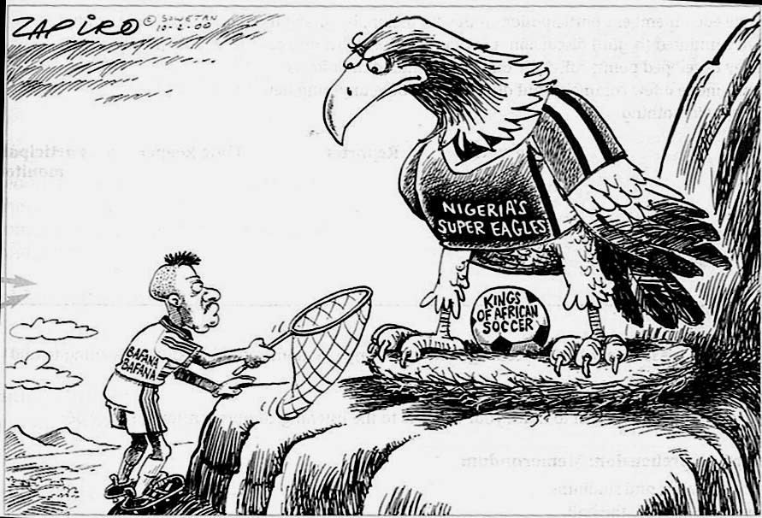

7.1 Write down only two visual clues that tell us that this cartoon is about soccer?
(2)
7.2 What does the drawing of the "Super Eagle"suggest about the Nigerian team?
(1)
7.3 The Bafana Bafana player is carrying a net. Is it going to be useful to him? Give a reason for your answer.
(2)
7.4 Do you think this cartoon is biased against South African Soccer? Give a reason for your answer.
(1)
MADAM AND EVE

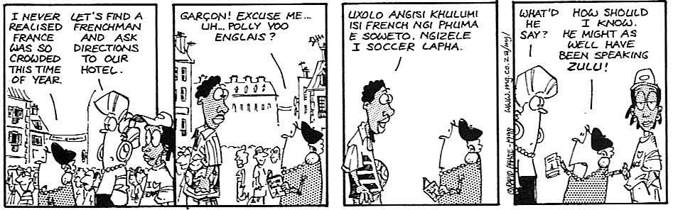
7.5 If the first frame of this cartoon were a photograph, would it be a long shot, a medium shot or a close-up?
(1)
7.6 What do you think Madam Anderson is asking in the second frame?
(1)
7.7 What may the following words in frame 3 mean?
7.7.1 Angisi
7.7.2 lapha
(2)
(10)
Total: 50
SECTION B
E.T. THE EXTRA-TERRESTRIAL

QUESTION 8 - MULTIPLE CHOICE QUESTIONS
Choose the correct answer. Write down the number of the question and the answer you have chose. If you select two answers it will be marked as incorrect.

8.1 In the opening scene an long, slender hand is shown that moves aside some branches. This hand has:

three fingers
four fingers
two fingers
five fingers

8.2 All the aliens working in front of the spaceship stops working when they hear

trucks arriving
a dog howl
a cat snarl
a horse nigh

8.3 The hearts of the aliens glow

blue
yellow
orange
red

8.4 When an alien reaches out to collect a fern the following animal is seen:

a dog
a cat
a fawn
a rabbit

8.5 The alien that is chased in the opening scenes of E. T. is running towards

a house
a hilltop
a spaceship
a tree

8.6 In the game of Dungeons and Dragons that the boys are playing, who has absolute power and is the game master?

Mike
Sam
Steve
Brian

8.7 Mike offers Elliot suggestions of what he may have seen outside in the yard. Which of the suggestions below is NOT one of Mike's

Leprechaun
Elf
Iguana
Psycho

8.8 In the scene where Elliot is waiting for the creature in the shed, the moon is

full
half
crescent
quarter

8.9 What is printed on the poster behind E.T. in the scene where E.T. mimics Elliott's movements with his hands:

SUPERSTAR
ASTROMAN
SNAGGLETOOTH
BOBA FETT

8.10 When Elliott tries to communicate for the first time with E.T., the alien puts the following object in his mouth

a fish
a toy car
a car
a doll

8.11 The first food Elliott opens when he goes to find food for him and E.T. is

a jar of peanut butter
a carton of milk
a sack of bread
the refrigerator

8.12 When Mike returns from school the day that Elliott stayed at home he is wearing a

green football blazer
yellow football blazer
white football blazer
red football blazer

8.13 When Mary arrives home and she sees Elliott's room, after Elliott stayed home for the day she calls it
filthy
unorganised
an accident
inconvenient

8.14 What is the colour of the little wagon that Gertie pulls to Elliott's room. She places a flower in the wagon

red
green
blue
yellow

8.15 Which of the following toys were not visible on the screen when Mary went upstairs to see what was in Elliott's closet?

Raggedy Ann
Bear
Monkey
Barbie

(15)

9. ABOUT THE MAKING OF THE MOVIE
9.1 Who is the director of the film? (name and surname)
(1)
9.2 Who is the writer of the film? (name or surname)
(1)
9.3 Why does the E.T. doll have such a long thin neck?
(1)
9.4 Mention three ways that the film crew used to make the E.T. doll come to life.
(3)
9.5 Why is the opening scene misty and diffused?
(1)
9.6 Which tactic did the filmmakers use to help the audience follow Elliott in the final chase scene on the bicycles?
(1)
9.7 State what the following colours symbolise in the movie:
9.7.1 purple
9.7.2 white
9.7.3 black and red
9.7.4 blue
(4)
9.8 Explain what the following techniques are used for:
9.8.1 Establishing shot
9.8.2 Transition scene
9.8.3 Point of attack
(6)
9.10 Several props are used in the movie. Why are the following props used?
9.10.1 keys
9.10.2 flowers
9.10.3 candy
9.10.4 the coffee cup in Mary’s hand
9.10.5 the father’s shirt found in the garage
(5)
9.11 Why does Spielberg never show the faces of adults in the beginning of the movie? Why does he only show Mary?
(2)
9.12 Who is the protagonist in the movie?
(1)
9.13 Who is the antagonist in the beginning of the movie?
(1)
9.14 In the scene where the antagonists are spying on the protagonist’s house, why do they show only the eye of the man that is doing the surveillance?
(1)
/28/
10. SCENES FROM THE FILM

10.1 Act 3 of the film begins with this scene. What is the function of this scene?

(1)

10.2 Why do they show only the reaction of one character when they try to restart E.T.'s heart?

(1)

10.3 Why did the colour of the vans of the antagonist change from dark to light?

(1)
10.4 Gertie asks her mother if she can wish for E.T. to come back. This scene is the pay off of an earlier scene. What is that earlier scene? Mention it in one sentence.

(1)
10.5 The flower regaining health is a pay off for earlier scenes in the movie. Why?

(1)
10.6 Mike has to drive the van to get away from the antagonists. This is also a pay off for an earlier scene in the movie. Mention the earlier scene in one sentence.

(1)

10.7 What does the convoy of police vehicles signify in the final chase scene of the film?

(1)
/50/
TOTAL: 100

